

**Internship Project Report**



Submitted in Partial Fulfillment of the Requirements for the Award of

The Degree of

Bachelor of Computer Application By

Mr. Abhi Kumar Roll No: 2210201666

Under the guidance of

## Mr. Atul Yadav Arun Kumar

Faculty of Computer Applications SiteCountry



INVERTIS UNIVERSITY, BAREILLY [U.P]



2024-25

# Table of Contents

|  |  |  |
| --- | --- | --- |
| **S. No.** | **Contents** | **Page No** |
| **1** | **Cover Page** | **I** |
| **2** | **Certificate** | **II** |
| **3** | **Acknowledgement** | **III** |
| **4** | **Completion Certificate** | **IV** |
| **5** | **Introduction** | **VI** |
| **6** | **Internship Tasks** | **IX** |
| **10** | **Learning Experience** | **XII** |
| **11** | **Conclusion** | **XV** |

**CERTIFICATE**

# TO WHOM IT MAY CONCERN

This is to certify that Abhi Kumar, student of Bachelor of Computer Applications, 5th Semester in our university has successfully completed his internship work for the partial fulfillment of the degree of Bachelor of Computer Applications for the session

2024-2025.

## Mr. Atul Yadav Dr. Akash Sanghi Dr. Manish Gupta

(Mentor) (HOD, Computer Applications) (Dean,ComputerApplications)

Name of Student: Abhi Kumar

Signature of Student: …………………………

# Acknowledgement

I would like to express my sincere gratitude to everyone who has supported and guided me throughout my internship at **SiteCountry**. This experience has been invaluable for my professional development, and I am deeply thankful to all those who contributed to making it such a meaningful learning journey.

First and foremost, I would like to thank my supervisor, Arun Kumar, for his continuous support, guidance, and encouragement. Their expertise and insights were crucial in helping me understand the complexities of web hosting and domain services. I am grateful for the constructive feedback and mentorship provided, which significantly enhanced my technical and professional skills.

I would also like to extend my thanks to my colleagues at SiteCountry, who were always willing to share their knowledge and experiences. Their collaborative spirit and teamwork created an excellent learning environment that helped me adapt quickly and feel comfortable taking on new challenges.

Special thanks to the management team at SiteCountry for providing this opportunity and for creating an environment that fosters learning and professional growth. The exposure to real-world projects, client interactions, and various hosting tools has been immensely valuable for my career.

Thank you all for making this internship a memorable and enriching experience.

**Abhi Kumar 09-09-2024**

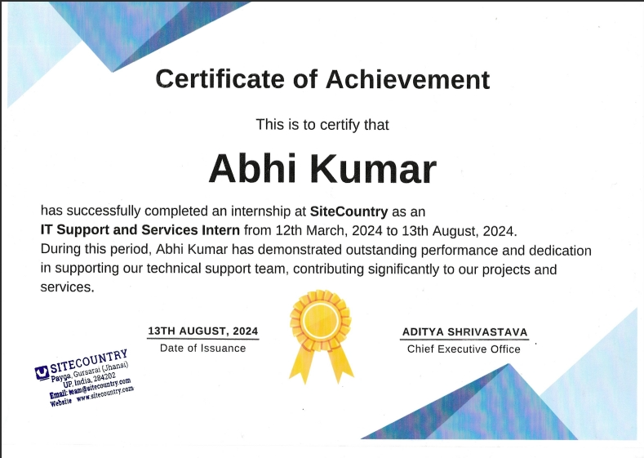

# Introduction

## Purpose and objectives of the Internship

**Purpose**

The internship at SiteCountry provided an in-depth, hands-on experience in the field of web hosting and domain registration services. As a critical part of the digital landscape, web hosting companies offer the backbone infrastructure required for websites to operate and be accessible to users worldwide. This internship allowed me to work closely with a team of professionals, gaining practical exposure to various aspects of web hosting, including website migrations, server management, SSL certificate installations, DNS configurations, and client support. Throughout the internship, I was actively involved in solving real-world technical challenges, providing customer support, and understanding the operations of a web hosting company.

I was able to develop a domain finder tool independently to check domain availability and suggest alternatives if the desired domain was not available. This project provided me with additional opportunities to apply my technical knowledge and further enhanced my problem-solving abilities. The overall experience provided invaluable insights into both the technical and operational aspects of the web hosting industry, preparing me for future opportunities in the field.

## Objectives of the Internship

1. **Gain Practical Experience**
   1. **Exposure to Web Hosting and Management Tools:** The internship provided hands-on experience with various web hosting tools and platforms, such as cPanel, Direct Admin, JetBackup, Softaculous, WordPress, CloudFlare, and HostBill. This exposure included performing tasks like website migration, server management, SSL installation, backup restoration, and DNS configuration.
   2. **Hands-On Learning with Hosting Services:** I actively engaged in configuring control panels, installing applications, managing domains and subdomains, setting up webmail integration, and optimizing server settings to meet client needs.
   3. **Understanding Hosting Operations and Client Support:** I gained insights into the operations of a web hosting company, focusing on customer support, service provisioning, and managing billing and account-related tasks. This included handling abuse cases, resolving customer complaints, and ensuring compliance with company policies.

## Enhance Technical Skills

* 1. **Website Migrations and Backup Restoration:** I learned to migrate websites between servers using different control panels, ensuring smooth transitions with minimal downtime. I also gained proficiency in restoring websites and databases using JetBackup.
  2. **WordPress Management and Troubleshooting:** The internship enhanced the intern's skills in managing WordPress installations, restoring core files, solving critical errors, and maintaining website functionality.
  3. **SSL Installation and Security Management:** I developed expertise in installing and managing SSL certificates using Let's Encrypt and Zero SSL, contributing to secure hosting environments.
  4. **DNS Configuration and Optimization:** Gained experience in managing DNS records (A, CNAME, MX, TXT, etc.) for domain pointing and email configuration, along with integrating Cloudflare for enhanced security and performance.

## Work on Real-World Projects

* 1. **Client Interaction and Support**: I worked directly with clients to gather requirements, provide updates, and incorporate feedback into technical support activities. This helped in understanding client expectations and delivering high-quality service.
  2. **Abuse Case Management:** I managed abuse cases reported by complainants regarding hosted websites, coordinating with relevant teams to address and resolve these issues in compliance with company policies.
  3. **Billing and Account Management:** I was involved in managing invoices, handling renewals, and overseeing account activities using HostBill, contributing to the financial management aspect of hosting services.

## Develop Problem-Solving and Adaptability Skills

* 1. **Troubleshooting and Resolving Technical Issues:** The internship involved diagnosing and solving various technical issues, such as website downtime, DNS misconfigurations, SSL errors, and critical WordPress problems.
  2. **Adaptability to New Tools and Environments:** I learned to adapt to different hosting environments and rapidly acquired knowledge of new tools and technologies, ensuring effective problem resolution.
  3. **Collaborative Problem Solving:** I worked closely with team members to brainstorm solutions, Utilizing collective expertise to effectively solve complex problems.

## Understand Professional Work Environment

* 1. **Workplace Dynamics and Team Collaboration:** I experienced the dynamics of a professional hosting environment, learning to work within a team, participate in meetings, and contribute effectively to discussions and decision-making.
  2. **Project Management and Service Delivery:** I gained exposure to project management methodologies, such as task prioritization, workflow management, and customer service delivery processes.

## Receive Constructive Feedback and Continuous Learning

* 1. **Performance Feedback and Growth:** I received regular feedback on my performance, identifying strengths and areas for improvement. This feedback was essential for my personal and professional growth.
  2. **Skill Development and Knowledge Enhancement:** Based on feedback, I focused on developing specific skills and addressing knowledge gaps to continuously improve my technical and soft skills.

# Internship Task

## Objective

The primary objective of this internship was to provide comprehensive support to customers encountering difficulties with their hosting services and to effectively manage abuse cases associated with hosted domains. This role involved ensuring a smooth and secure hosting experience for clients by addressing their technical issues and concerns promptly.

The internship aimed to:

Deliver Technical Support: Offer hands-on assistance with various hosting-related challenges, including website and server issues, to enhance customer satisfaction and operational efficiency.

Enhance Hosting Operations**:** Contribute to the smooth functioning of web hosting operations through effective configuration, migration, and management tasks.

Improve Communication Skills: Develop professional communication skills by interacting with clients, understanding their needs, and providing clear and actionable solutions.

Gain Technical Proficiency: Acquire in-depth knowledge and hands-on experience with web hosting tools and platforms, furthering expertise in the field.

## Tasks

**Provide Support to Customers Facing Difficulties:** Assist clients with technical issues related to their hosting services, including troubleshooting website problems, resolving server issues, and guiding them through control panel functionalities. Offer timely and effective solutions to ensure customer satisfaction.

**Manage Abuse Cases:** Handle abuse cases reported for hosted domains, including investigating complaints, communicating with affected clients, and coordinating with relevant teams to resolve issues. Take necessary actions to address and mitigate abuse while maintaining compliance with company policies.

**Configure Websites:** Assist in the setup and configuration of websites, including installing applications through tools like Softaculous, managing DNS settings, and ensuring proper integration with webmail and other services.

**SSL Installation and Management:** Install and manage SSL certificates for client websites to ensure secure data transmission. Handle SSL configurations using tools such as Let's Encrypt and Zero SSL.

**Website Migrations:** Facilitate the migration of websites between servers, ensuring minimal downtime and smooth transitions. Use tools and control panels to manage and execute migrations effectively.

**Backup and Restoration:** Perform backups and restorations of websites and databases using JetBackup, ensuring data integrity and availability.

**Client Communication:** Engage with clients to gather requirements, provide updates on ongoing tasks, and address any concerns or feedback. Maintain clear and professional communication throughout the support process.

**Billing and Account Management:** Assist with managing invoices, handling account renewals, and performing other billing-related tasks using HostBill.

**Website Performance Optimization:** Monitor and optimize website performance to ensure fast loading times and efficient operation, using tools and techniques to enhance user experience.

**Documentation and Reporting:** Maintain detailed documentation of support activities, configurations, and changes made during the internship. Prepare reports on common issues and resolutions to assist in improving support processes.

**Workshops and Mentorship Sessions:** Participate in internal workshops and mentorship sessions to gain insights from experienced professionals, enhance technical skills, and stay updated with industry best practices.

**Client Interactions and Feedback:** Actively interact with clients to understand their needs, provide technical support, and gather feedback on service quality. Use this feedback to improve service delivery and client satisfaction.

**Monitor New Orders:** Actively check new orders to ensure they are processed and executed efficiently. Verify that all orders are fulfilled correctly and promptly address any issues that may arise.

**Tool Development:** Developed a Domain whois information lookup tool to check the details of domains and suggest alternative domains such as the registrar, date of registration, expiration & Updation, Domain Status, Nameservers, This project involved coding and integrating various APIs to offer real-time domain availability and suggestions.

Domain WhoIS information Lookup Tool

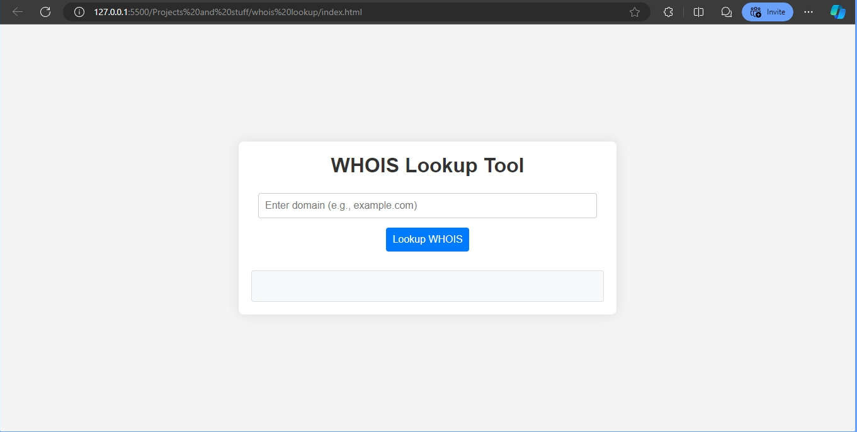

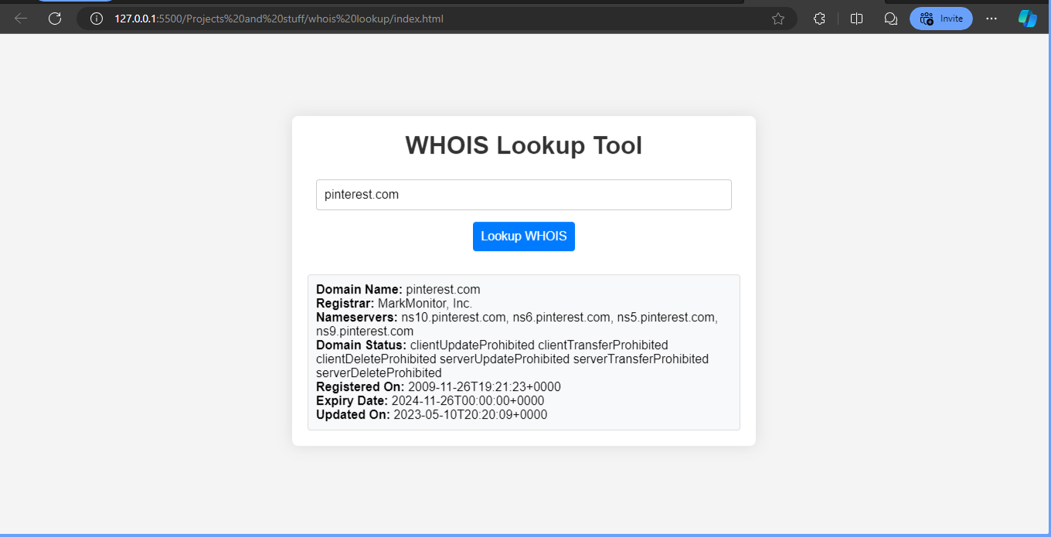

# Learning Experience

## Technical Skills and Knowledge

* 1. **Web Hosting Tools and Platforms:** Gained hands-on experience with essential web hosting tools such as cPanel, DirectAdmin, JetBackup, Softaculous, WordPress, Let's Encrypt, and HostBill. Developed proficiency in performing website migrations, managing server settings, installing SSL certificates, and configuring DNS records.
  2. **Website Management:** Acquired skills in configuring and optimizing websites, including handling WordPress installations, troubleshooting core files, resolving critical errors, and ensuring website performance and security.
  3. **SSL Certificate Management:** Developed expertise in installing and managing SSL certificates using Let's Encrypt and Zero SSL, contributing to secure hosting environments
  4. .**DNS Configuration:** Gained experience in managing DNS records for domain pointing, email configuration, and integrating Cloudflare for enhanced security and performance.
  5. **1.5 Backup and Restoration:** Proficiently used JetBackup to perform backups and restorations, ensuring data integrity and availability for client websites.

## Professional Skills and Experience

* 1. **Customer Support:** Enhanced skills in providing effective customer support by addressing technical issues, resolving client concerns, and offering clear guidance on hosting services and control panel functionalities.
  2. **Abuse Case Management:** Acquired experience in handling abuse cases, including investigating complaints, communicating with clients, and coordinating with internal teams to resolve issues in compliance with company policies.
  3. **Billing and Account Management:** Gained practical experience in managing invoices, handling account renewals, and performing billing-related tasks using HostBill.
  4. **Client Communication:** Improved communication skills through direct interactions with clients, understanding their needs, providing updates, and addressing feedback to ensure high-quality service delivery.

## Soft Skills

* 1. **Problem-Solving:** Developed strong problem-solving abilities by troubleshooting technical issues, resolving website errors, and managing complex scenarios related to hosting and domain services.
  2. **Adaptability:** Demonstrated flexibility in adapting to new tools, technologies, and changing project requirements, ensuring effective problem resolution in various hosting environments.
  3. **Team Collaboration:** Enhanced teamwork skills by working closely with colleagues, participating in meetings, and contributing to collaborative problem-solving efforts.

## Knowledge Gained

* 1. **Web Hosting Operations:** Gained a comprehensive understanding of web hosting operations, including technical and administrative aspects such as server management, client support, and service provisioning.
  2. **Industry Best Practices:** Acquired knowledge of industry best practices in web hosting, including security measures, performance optimization, and effective customer service techniques.
  3. **Project Management:** Developed insights into project management methodologies and practices, including task prioritization, workflow management, and service delivery processes.

## Personal Growth

* 1. **Confidence Building:** Gained confidence in handling complex technical issues and interacting with clients, which contributed to a more assertive and proactive approach in problem-solving and decision-making.
  2. **Independence and Initiative:** Demonstrated the ability to work independently and take initiative by developing a domain finder tool, which showcased creativity and self- reliance in addressing real-world challenges.
  3. **Time Management:** Improved time management skills by balancing multiple tasks and responsibilities effectively, meeting deadlines, and prioritizing tasks to ensure timely and efficient completion.
  4. **Professionalism:** Developed a deeper understanding of professional work ethics and standards, including maintaining a positive attitude, handling feedback constructively, and contributing to a collaborative work environment.

## Workplace Culture

* 1. **Professional Environment:** Experienced the dynamics of a professional hosting environment, including workplace culture, team dynamics, and organizational structure.
  2. **Team Dynamics:** Learned to navigate and contribute to a collaborative work environment, understanding the importance of clear communication, mutual support, and effective teamwork.
  3. **Client-Centric Approach:** Gained an appreciation for the client-centric approach of the company, focusing on delivering high-quality services and maintaining strong client relationships.

# Conclusion

## Summary of the Overall Internship Experience

1. **Introduction**

The internship at SiteCountry aimed to provide practical, hands-on experience in web hosting and domain management, exposing me to real-world challenges and operational practices within the industry.

## Objectives and Expectations

The primary objectives were to support customers facing difficulties, manage abuse cases, and develop technical solutions, such as a domain finder tool. Expectations included gaining proficiency in web hosting tools, improving client support skills, and understanding the operational aspects of a hosting company.

## Roles and Responsibilities

My role involved a diverse set of responsibilities, including providing technical support, managing abuse cases, configuring websites, installing SSL certificates, performing website migrations, and developing a domain finder tool. I also participated in workshops, client interactions, and monitored new orders to ensure timely execution.

## Skills and Knowledge Gained

Throughout the internship, I gained substantial skills and knowledge, including:

* 1. Proficiency in web hosting tools such as cPanel, DirectAdmin, JetBackup, Softaculous, WordPress, and HostBill.
  2. Expertise in SSL installation and DNS configuration.
  3. Experience in website migration, backup restoration, and managing abuse cases.
  4. Development of a domain finder tool that checks domain availability and suggests alternatives.
  5. Enhanced client support and communication skills, along with insights into the billing and account management processes.

## Challenges and Solutions

Several challenges arose, such as managing complex technical issues and handling abuse cases. Solutions involved leveraging technical skills, collaborating with the team, and implementing effective problem-solving strategies to address and resolve issues efficiently.

## Key Achievement

One of the key achievements was the successful development of a domain finder tool. This project showcased my ability to create practical solutions and apply my technical knowledge to solve real- world problems.

## Feedback and Mentorship

Throughout the internship, I received constructive feedback from supervisors and mentors, which was crucial for my professional growth. Mentorship sessions and regular feedback helped me refine my skills and improve my performance.

## Reflection and Personal Growth

The internship experience significantly contributed to my personal growth, enhancing my confidence, adaptability, and problem-solving abilities. It provided a deep understanding of the professional work environment and prepared me for future career opportunities.

## Conclusion

In conclusion, the internship at SiteCountry was an invaluable experience that enriched my understanding of web hosting and domain management. The skills and knowledge gained have equipped me for future roles in the industry, and the experience has been instrumental in my professional and personal development. I am grateful for the opportunity and look forward to applying these insights to my future career endeavors.